**Empathy Phase**

**Empathize & Discover**

|  |  |
| --- | --- |
| Date | 14 APRIL 2025 |
| Team ID | SWTID1742640402 |
| Project Name | MyRide |
| Maximum Marks | 4 Marks |

To deeply understand the needs and pain points of both passengers and drivers, we conducted user surveys, interviews, and ride-along observations. The insights were organized into an Empathy Map Canvas, revealing key behavioral and emotional patterns.

**Passenger Empathy Map**

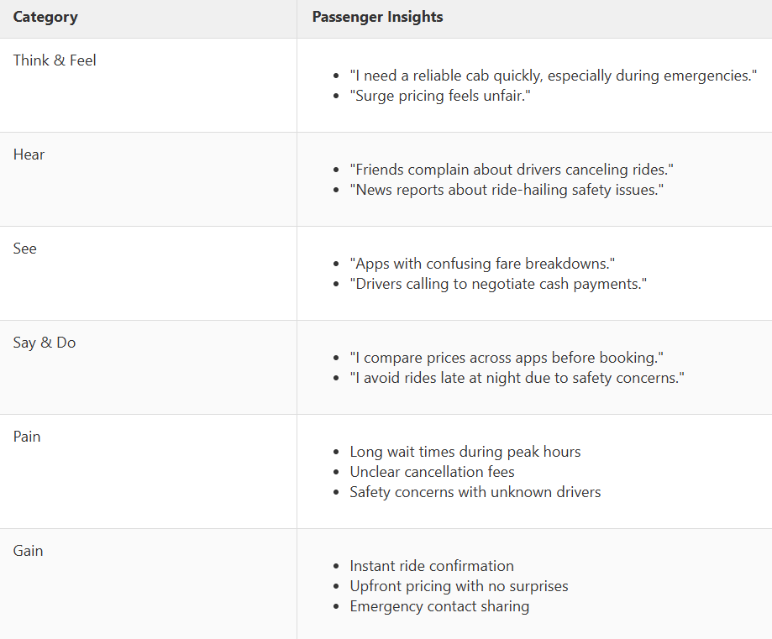

**Driver Empathy Map**

